**Climate change Data Analysis based on World Bank Data**

Forests and arable land are both crucial elements of land use, and changes in one can significantly affect the other. Forests play a vital role in regulating the climate, providing habitats for biodiversity, and supporting numerous ecosystem services essential for human well-being. Conversely, arable land is critical for food production and can have significant social and economic benefits. However, deforestation for the creation of arable land can have detrimental environmental consequences, such as soil erosion, loss of biodiversity, and carbon emissions. To analyze the relationship between forest area and arable land, 15 countries were selected, including Eastern and Southern Africa, Australia, Portugal, Russia, Pakistan, Canada, Switzerland, China, the United States of America, Cuba, Egypt, France, Kenya, and the United Kingdom.

An area chart is useful for showing trends in forest area percentage over time. It allows us to see how forest area percentage has changed over the years and can help identify any patterns or trends in the data. This can help identify years or periods of time where deforestation or reforestation efforts may have been particularly successful or unsuccessful.

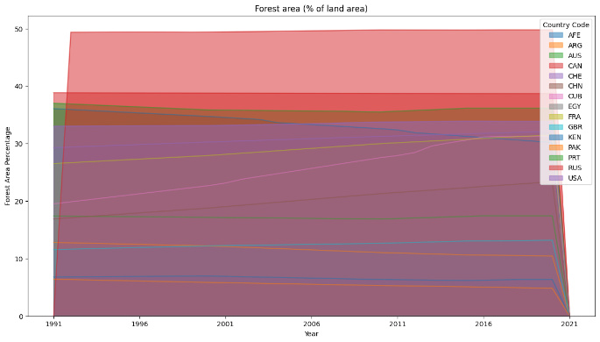

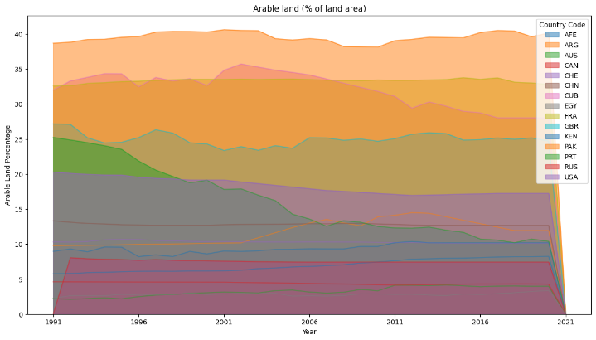

Bar chart: A bar chart is useful for comparing the forest area percentage of different countries or regions. The bar chart presented in the figure below describe that the forest area 5 decreases in the Africa Eastern and Southern, Argentina, Kenya, Pakistan while Chine, Cuba, France and United Kingdom shows the increase in the forest area and the Canada, Australia and Russia shows consistent behavior in the forest area.

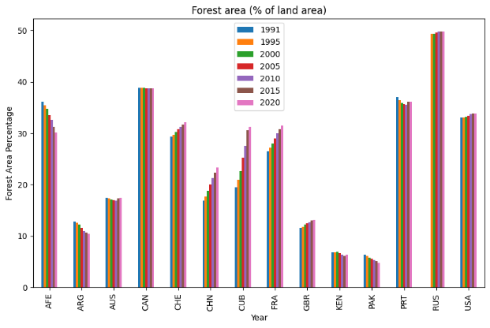

The countries like Pakistan, Cuba and France shows high percentage of the arable land compared with others.

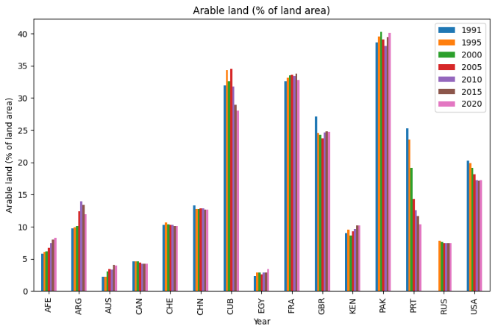

Boxplot: A boxplot is useful for showing the distribution of forest area percentage across different countries. The presented result shows that forest region is around 40 to 50 % while the arable land the values lies under the 20. This can help identify countries with high or low forest area percentages and potential outliers that may require further investigation.

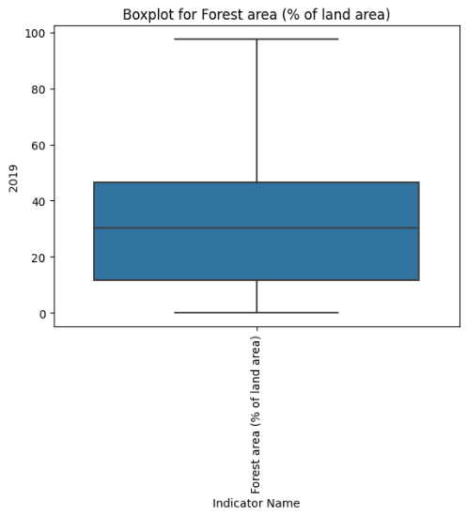

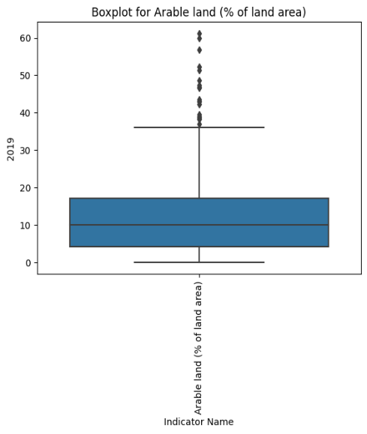

The Forest area % data shows the forest area percentage of 261 countries from 2012 to 2020, with a mean forest area percentage of around 32%. However, there is significant variation in forest area percentage among different countries, ranging from 0% to 97%, and with a high standard deviation indicating a lot of variability in forest area percentage across countries. Despite a slight increase in forest area percentage in 2017, the data suggests ongoing deforestation is a concern, as shown by the slight decrease in the mean forest area percentage from 2012 to 2017.

The data provided shows the arable land area from 1960 to 2020 for 254 countries. The mean arable land area has increased from 12.5 in 1961 to 13.5 in 2020, with a significant variation in arable land area between countries due to factors such as climate, soil type, and economic conditions. The data also shows interesting trends and potential impacts of climate change on arable land area, as some countries experienced a decline in arable land area due to environmental factor.

The Line chart for Forest area and arable land is presented in the figures below to describe the correlation between the different countries.

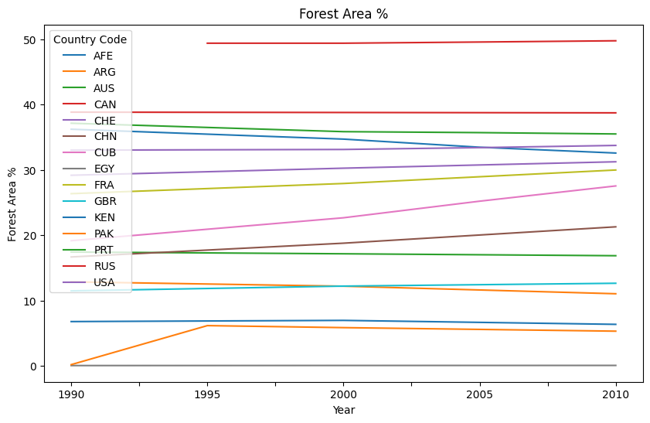

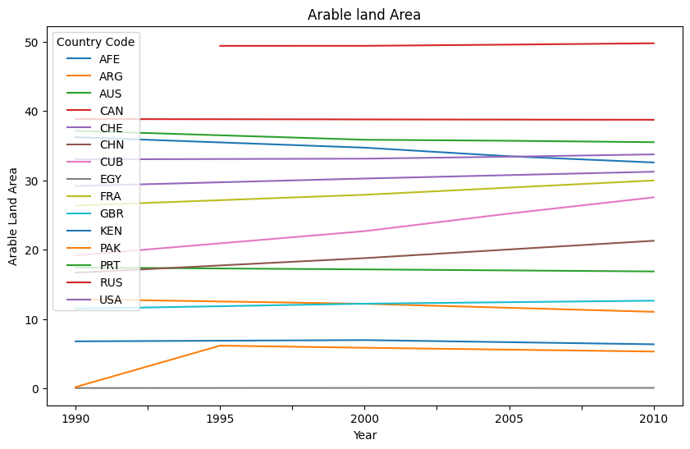

Understanding the relationship between forest area and arable land area is important for making informed land use decisions that balance competing demands for natural resources and promote sustainable development. It can inform policy decisions related to agriculture, forestry, land use planning, and climate change mitigation and adaptation. Moreover, it can help identify areas where conservation and sustainable development can be mutually reinforcing, and where conflicts between competing land uses need to be addressed.